QuickCMC:
Test Module
Name: | OMICRON QuickCMC | Version: | 5.00
Test Start: | 05-Aug-2026 19:41:15 | Test End: | 05-Aug-2026 19:49:01
User Name: |  | Manager:
Company:
Test Results

Generator Settings
Table Inputmode |  |  |  | Parameters (All values are secondary)
Direct |  |  |  | V L1-E V L2-E V L3-E I L1 I L2 I L3 |  |  | 0.00 V 0.00 V 0.00 V 1.000 A 1.000 A 1.000 A |  |  |  |  | 0.00 ° -120.00 ° 120.00 ° 0.00 ° -120.00 ° 120.00 ° |  |  | 60.000 Hz 60.000 Hz 60.000 Hz 60.000 Hz 60.000 Hz 60.000 Hz

V L1-E | 0.000V | 0.00°
V L2-E | 0.000V | -120.00°
V L3-E | 0.000V | 120.00°
I L1 | 1.000A | 0.00°
I L2 | 1.000A | -120.00°
I L3 | 1.000A | 120.00°

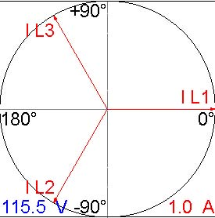
Binary Inputs
Name | Slope | Time
Trip | 0
Start | 0
Overload | 0

Table Inputmode |  |  |  | Parameters (All values are secondary)
Direct |  |  |  | V L1-E V L2-E V L3-E I L1 I L2 I L3 |  |  | 0.00 V 0.00 V 0.00 V 20.00 mA 0.00 A 0.00 A |  |  |  |  | 0.00 ° -120.00 ° 120.00 ° 0.00 ° -120.00 ° 120.00 ° |  |  | 60.000 Hz 60.000 Hz 60.000 Hz 60.000 Hz 60.000 Hz 60.000 Hz

V L1-E | 0.000V | 0.00°
V L2-E | 0.000V | -120.00°
V L3-E | 0.000V | 120.00°
I L1 | 0.020A | 0.00°
I L2 | 0.000A | -120.00°
I L3 | 0.000A | 120.00°

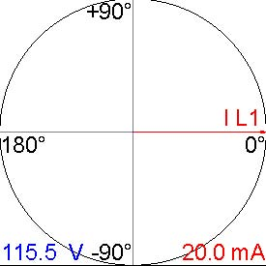
Name | Slope | Time
Trip | 0->1 | 0.053s
Start | 1->0 | n/a
Overload | 1->0 | n/a

Table Inputmode |  |  |  | Parameters (All values are secondary)
Direct |  |  |  | V L1-E V L2-E V L3-E I L1 I L2 I L3 |  |  | 0.00 V 0.00 V 0.00 V 30.00 mA 0.00 A 0.00 A |  |  |  |  | 0.00 ° -120.00 ° 120.00 ° 0.00 ° -120.00 ° 120.00 ° |  |  | 60.000 Hz 60.000 Hz 60.000 Hz 60.000 Hz 60.000 Hz 60.000 Hz

V L1-E | 0.000V | 0.00°
V L2-E | 0.000V | -120.00°
V L3-E | 0.000V | 120.00°
I L1 | 0.030A | 0.00°
I L2 | 0.000A | -120.00°
I L3 | 0.000A | 120.00°

+90° | I L1
180° | 0°
-90° 115.5 V | 40.0 mA

Name | Slope | Time
Trip | 0->1 | 0.051s
Start | 1->0 | n/a
Overload | 1->0 | n/a

Table Inputmode |  |  |  | Parameters (All values are secondary)
Direct |  |  |  | V L1-E V L2-E V L3-E I L1 I L2 I L3 |  |  | 0.00 V 0.00 V 0.00 V 0.00 A 20.00 mA 0.00 A |  |  |  |  | 0.00 ° -120.00 ° 120.00 ° 0.00 ° -120.00 ° 120.00 ° |  |  | 60.000 Hz 60.000 Hz 60.000 Hz 60.000 Hz 60.000 Hz 60.000 Hz

V L1-E | 0.000V | 0.00°
V L2-E | 0.000V | -120.00°
V L3-E | 0.000V | 120.00°
I L1 | 0.000A | 0.00°
I L2 | 0.020A | -120.00°
I L3 | 0.000A | 120.00°

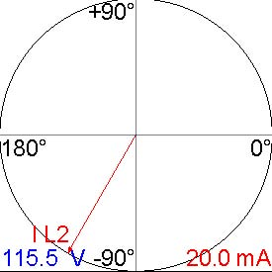
Name | Slope | Time
Trip | 0->1 | 0.052s
Start | 1->0 | n/a
Overload | 1->0 | n/a

Table Inputmode |  |  |  | Parameters (All values are secondary)
Direct |  |  |  | V L1-E V L2-E V L3-E I L1 I L2 I L3 |  |  | 0.00 V 0.00 V 0.00 V 0.00 A 30.00 mA 0.00 A |  |  |  |  | 0.00 ° -120.00 ° 120.00 ° 0.00 ° -120.00 ° 120.00 ° |  |  | 60.000 Hz 60.000 Hz 60.000 Hz 60.000 Hz 60.000 Hz 60.000 Hz

V L1-E | 0.000V | 0.00°
V L2-E | 0.000V | -120.00°
V L3-E | 0.000V | 120.00°
I L1 | 0.000A | 0.00°
I L2 | 0.030A | -120.00°
I L3 | 0.000A | 120.00°

+90°
180° | 0°
I L2
-90° 115.5 V | 40.0 mA

Name | Slope | Time
Trip | 0->1 | 0.048s
Start | 1->0 | n/a
Overload | 1->0 | n/a

Table Inputmode |  |  |  | Parameters (All values are secondary)
Direct |  |  |  | V L1-E V L2-E V L3-E I L1 I L2 I L3 |  |  | 0.00 V 0.00 V 0.00 V 0.00 A 0.00 A 20.00 mA |  |  |  |  | 0.00 ° -120.00 ° 120.00 ° 0.00 ° -120.00 ° 120.00 ° |  |  | 60.000 Hz 60.000 Hz 60.000 Hz 60.000 Hz 60.000 Hz 60.000 Hz

V L1-E | 0.000V | 0.00°
V L2-E | 0.000V | -120.00°
V L3-E | 0.000V | 120.00°
I L1 | 0.000A | 0.00°
I L2 | 0.000A | -120.00°
I L3 | 0.020A | 120.00°

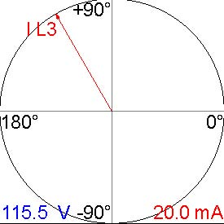
Name | Slope | Time
Trip | 0->1 | 0.055s
Start | 1->0 | n/a
Overload | 1->0 | n/a

Table Inputmode |  |  |  | Parameters (All values are secondary)
Direct |  |  |  | V L1-E V L2-E V L3-E I L1 I L2 I L3 |  |  | 0.00 V 0.00 V 0.00 V 0.00 A 0.00 A 30.00 mA |  |  |  |  | 0.00 ° -120.00 ° 120.00 ° 0.00 ° -120.00 ° 120.00 ° |  |  | 60.000 Hz 60.000 Hz 60.000 Hz 60.000 Hz 60.000 Hz 60.000 Hz

V L1-E | 0.000V | 0.00°
V L2-E | 0.000V | -120.00°
V L3-E | 0.000V | 120.00°
I L1 | 0.000A | 0.00°
I L2 | 0.000A | -120.00°
I L3 | 0.030A | 120.00°

+90° I L3
180° | 0°
-90° 115.5 V | 40.0 mA

Name | Slope | Time
Trip | 0->1 | 0.052s
Start | 1->0 | n/a
Overload | 1->0 | n/a

Table Inputmode |  |  |  | Parameters (All values are secondary)
Direct |  |  |  | V L1-E V L2-E V L3-E I L1 I L2 I L3 |  |  | 0.00 V 0.00 V 0.00 V 20.00 mA 20.00 mA 20.00 mA |  |  |  |  | 0.00 ° -120.00 ° 120.00 ° 0.00 ° -120.00 ° 120.00 ° |  |  | 60.000 Hz 60.000 Hz 60.000 Hz 60.000 Hz 60.000 Hz 60.000 Hz

V L1-E | 0.000V | 0.00°
V L2-E | 0.000V | -120.00°
V L3-E | 0.000V | 120.00°
I L1 | 0.020A | 0.00°
I L2 | 0.020A | -120.00°
I L3 | 0.020A | 120.00°

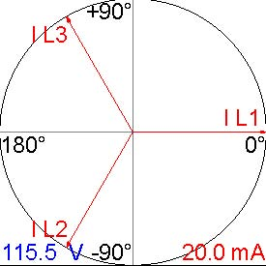
Name | Slope | Time
Trip | 0->1 | 0.052s
Start | 1->0 | n/a
Overload | 1->0 | n/a

Table Inputmode |  |  |  | Parameters (All values are secondary)
Direct |  |  |  | V L1-E V L2-E V L3-E I L1 I L2 I L3 |  |  | 0.00 V 0.00 V 0.00 V 30.00 mA 30.00 mA 30.00 mA |  |  |  |  | 0.00 ° -120.00 ° 120.00 ° 0.00 ° -120.00 ° 120.00 ° |  |  | 60.000 Hz 60.000 Hz 60.000 Hz 60.000 Hz 60.000 Hz 60.000 Hz

V L1-E | 0.000V | 0.00°
V L2-E | 0.000V | -120.00°
V L3-E | 0.000V | 120.00°
I L1 | 0.030A | 0.00°
I L2 | 0.030A | -120.00°
I L3 | 0.030A | 120.00°

+90°
I L3
 | I L1
180° | 0°
I L2
-90° 115.5 V | 40.0 mA

Name | Slope | Time
Trip | 0->1 | 0.048s
Start | 1->0 | n/a
Overload | 1->0 | n/a

Summary
9 tests passed, 0 tests failed, 0 tests not assessed 100.00% passed
Test passed (manually assessed)

